**CS 207   
Programming Assignment 2**

*Edge Detection, Morphological Processing and Digital Halftoning*

**Sardor Akhmedjonov**

**NetID: sa524  
Email:** [**sardor.akhmedjonov@dukekunshan.edu.cn**](mailto:sardor.akhmedjonov@dukekunshan.edu.cn)

**Problem 3: Digital Halftoning**

**Description of Motivation**

Digital halftoning is an essential image processing technique that allows for the simulation of continuous-tone images on devices that can only display binary images. The motivation behind this project was to explore various halftoning techniques to better understand how they affect the quality and perceptual likeness of the original image when reproduced with limited color depth.

**Description of Approach and Procedures**

The project was tackled by implementing four distinct halftoning techniques on the given image barbara.raw:

* **Fixed Threshold Dithering:** A threshold T was chosen to convert the grayscale image into a binary one.
* **Random Dithering:** Random thresholds were generated to add stochasticity to the dithering process.
* **Dithering Matrix (Pattern):** Utilized 2x2 and 4x4 Bayer matrices to create patterns for halftoning.
* **Error Diffusion (Floyd-Steinberg's algorithm):** This method diffuses the quantization error pixel-by-pixel to neighboring pixels.

**Results from the Provided Testing Images**

Barbara.raw image were provided, and the implemented code was used to process this images, applying the above-mentioned procedures. Visual results, such as Fixed Threshold Dithering, Random Dithering, Dithering Matrix (Pattern) and Error Diffusion (Floyd-Steinberg's algorithm), were successfully generated and displayed using matplotlib.

**Discussion of Approach and Results**

The fixed threshold dithering method was straightforward but produced images with a loss of detail. Random dithering introduced noise, which made the image appear grainy but preserved more detail. The pattern dithering method provided a good balance between detail preservation and noise. The error diffusion method was the most complex but yielded the highest quality results, closely resembling the original image.

**Answers to Non-Programming Questions**

See below.

**Findings from Own Created Testing Images**

AI-generated content (AIGC) tools were utilized to create additional testing images for each exercise. Applying the provided code to these images yielded successful results consistent with those obtained from the provided images. For each question, the AI-generated image and the processed results were examined, leading to a deeper understanding and verification of the image processing techniques implemented.

**Analysis Report on the Fixed Threshold Dithering Implementation**

**Code Overview**

The provided Python code implements the Fixed Threshold Dithering technique on the 'barbara.raw' image. This method is a simple form of digital halftoning, where each pixel in a grayscale image is converted to either black or white based on a fixed threshold value.

**Code Breakdown**

1. **Importing Libraries:** The code begins by importing necessary libraries - **numpy** for numerical operations and **matplotlib.pyplot** for plotting the image.
2. **Threshold Definition:** A threshold value **T** is set to 127. This value is used to determine whether a pixel will be turned black or white. In this context, 127 is a midpoint in the 0-255 grayscale range, offering a balanced approach to thresholding.
3. **Reading the Image Data:**
   * The path to the 'barbara.raw' image is defined.
   * The image is presumed to be 256x256 pixels in size, as indicated in the problem description.
   * The image data is read from the file, converted to an 8-bit unsigned integer array, and reshaped to match the image's dimensions.
4. **Applying Fixed Threshold Dithering:**
   * The **np.where** function is utilized to compare each pixel against the threshold **T**.
   * Pixels with values less than 127 are set to 0 (black), and those equal to or greater than 127 are set to 255 (white), creating a binary image.
5. **Displaying the Result:**
   * The resulting binary image is displayed using **matplotlib.pyplot**, with the colormap set to grayscale.
   * Axes are turned off for a cleaner presentation of the image.

Observations and Insights

* **Simplicity and Efficiency:** The implementation is straightforward and computationally efficient, making it suitable for scenarios where quick processing is required.
* **Contrast and Detail:** This method tends to produce images with high contrast. However, it might lead to the loss of subtle details, especially in areas with mid-range grayscale values.
* **Arbitrary Threshold Limitation:** The choice of a fixed threshold (127 in this case) is arbitrary and may not be optimal for all images. Different images might require different threshold values for better results.

**Conclusion**

The Fixed Threshold Dithering code provides a basic yet effective way to convert grayscale images into binary format. While it excels in its simplicity and speed, the technique may not be ideal for preserving detailed information in images with varying brightness levels. Its effectiveness largely depends on the nature of the image and the chosen threshold value. This method is best suited for images where high contrast is desired and fine details are not a priority.

Analysis Report on the Random Dithering Implementation

**Overview**

The provided code snippet implements Random Dithering, a technique used in digital halftoning to convert a grayscale image into a binary image. Unlike fixed threshold dithering, random dithering employs random thresholds, which helps in reducing the appearance of patterns and adds a level of randomness to the image.

**Step-by-Step Description of Procedures**

**Import Libraries:**

The code begins by importing numpy and matplotlib.pyplot, essential for handling array operations and visualizing the results, respectively.

**Loading the Image:**

The image 'barbara.raw' is read into a numpy array using the np.fromfile method. The image is assumed to be square and in 8-bit grayscale format.

The size of the image is calculated by taking the square root of the total number of pixels, assuming a square image.

**Reshaping the Array into an Image:**

The linear array of image data is reshaped into a 2D array representing the image.

**Applying Fixed Threshold Dithering:**

Initially, a fixed threshold dithering is applied as a reference, using a threshold (T = 127), which is less relevant to the random dithering process but useful for comparison.

**Generating Random Values:**

Two sets of random values are generated:

uniform_random_values: Using a uniform distribution ranging from 0 to 255.

triangular_random_values: Using a triangular distribution with left, mode (midpoint), and right parameters set to 0, 127.5, and 255, respectively.

**Applying Random Dithering:**

Two binary images are created by comparing the original image with each set of random values.

output_image_uniform: Pixels are set to black or white based on a comparison with uniformly distributed random values.

output_image_triangular: A similar process, but using triangularly distributed random values.

**Visualizing the Results:**

The original image and the two randomly dithered images (uniform and triangular) are displayed side by side for comparison.

**Observations and Insights**

**Randomness in Dithering:** The use of randomness in dithering helps in breaking up patterns that can occur in fixed threshold dithering, leading to a more natural and less structured appearance.

**Uniform vs. Triangular Distribution:** The choice of distribution for random values affects the final output. Uniform distribution provides an even probability across all grayscale values, while the triangular distribution gives more weight to the mid-range values.

**Visual Texture:** Random dithering introduces a textured effect to the image, which can be more pleasing to the eye compared to the stark contrasts of fixed threshold dithering.

**Conclusion**

Random Dithering, as implemented in the provided code, offers a unique approach to binary image conversion. By incorporating randomness, it overcomes some of the limitations of fixed threshold dithering, such as pattern formation and loss of detail. The comparison between uniform and triangular distributions in the code highlights the impact of random value generation methods on the visual quality of the dithered image. This technique is particularly useful in applications where a more natural, less structured representation of grayscale images is desired.

**Report on Dithering Algorithm Implementation**

**Code Overview**

The provided code snippet is an implementation of the Bayer dithering algorithm to create halftone images of a raw image file, specifically the "Barbara" image. Dithering is a technique used to create the illusion of color depth in images with a limited color palette. In this case, the code uses a binary color palette to simulate grayscale images.

**Code Breakdown**

* **load_raw_image function**: Reads a raw image file and converts it into a NumPy array of a specified size. It is used to load the "Barbara" image into a format suitable for processing.
* **bayer_matrix function**: Constructs a Bayer matrix of a given order using recursion. The Bayer matrix is a dithering matrix that determines the pattern of pixels to simulate different shades of gray.
* **dither_image function**: Applies the dithering process to the image using the threshold matrix, which is derived from the Bayer matrix. It compares each pixel value in the image against the corresponding value in the threshold matrix to determine whether to turn the pixel on (white) or off (black).
* **Bayer Matrices Creation**: The code creates 2x2 and 4x4 Bayer matrices using the **bayer_matrix** function. These matrices are used to dither the image at different levels of detail.
* **Dithering Process**: The original Barbara image is dithered using the 2x2 and 4x4 Bayer matrices to create two dithered images.
* **Plotting**: The original and dithered images are displayed using Matplotlib to visualize the results of the dithering process.

**Observations and Insights**

* The dithered images show a pixelated version of the original, with the 4x4 dithered image having a smoother appearance than the 2x2 due to the larger matrix providing a finer gradation of shades.
* The original image has continuous-tone grayscale, while the dithered images use only black and white pixels to simulate the grayscale. The pattern of these pixels follows the Bayer matrix used.
* The effectiveness of the dithering is evident in the preservation of detail, despite the limited color palette. For instance, the shading and contours of Barbara's face are recognizable.
* There's a trade-off between the resolution of the dithering matrix and the output image's detail. Larger matrices can produce finer detail but may introduce more complexity and processing time.

**Conclusion**

The implementation of the Bayer dithering algorithm successfully demonstrates how a binary color palette can simulate a grayscale image. Through careful construction of the Bayer matrices and the thresholding process, the code effectively transforms the continuous-tone "Barbara" image into halftoned versions, preserving as much detail and texture as possible. This process is crucial for printing technologies that cannot reproduce a wide range of colors or shades, proving that dithering is a powerful technique for image processing where color limitations exist. The code is well-structured, and its modular design allows for easy testing and adaptation to different images and dithering matrix sizes.

**Implementation and Analysis of Floyd-Steinberg Dithering with Serpentine Scanning**

**Introduction**

This report presents a detailed analysis of the implementation of the Floyd-Steinberg dithering algorithm enhanced with serpentine scanning. Dithering is a well-known technique used in image processing to create the illusion of color depth in images with a limited color palette. The Floyd-Steinberg algorithm, specifically, is a classic approach for error diffusion in image halftoning. The integration of serpentine scanning is intended to mitigate visual artifacts and improve the quality of the binary image output.

**Code Overview**

The provided Python script transforms a grayscale image into a binary (black and white) image through a dithering process. This process utilizes Floyd-Steinberg's error diffusion technique in conjunction with serpentine scanning to distribute quantization errors of pixel values.

**Code Breakdown**

**Image Loading**

The script starts by reading a raw image file, assuming it is a square, and reshapes it into a two-dimensional NumPy array representing pixel intensities.

**Dithering Function**

The **floyd_steinberg_dither** function is the core of the script. It iterates over each pixel, determining whether it should be turned black or white based on a threshold. The quantization error is then computed and propagated to neighboring pixels in a weighted fashion. The serpentine pattern alters the direction of scanning on each row, which helps in reducing directional artifacts.

**Error Propagation**

The error is distributed to the right, bottom-left, bottom, and bottom-right neighboring pixels with respective weights of 7/16, 3/16, 5/16, and 1/16. This distribution only occurs within the bounds of the image to prevent index errors.

**Observations and Insights**

Upon analyzing the output image, it is evident that the algorithm effectively maintains the high-frequency details and overall structure. The serpentine scanning method demonstrates a reduction in horizontal pattern artifacts compared to traditional single-direction scanning. Nonetheless, the algorithm might introduce a grainy texture, especially noticeable in smoother areas of the original image.

**Conclusion**

The implemented Floyd-Steinberg algorithm with serpentine scanning proves to be an efficient method for dithering images. It preserves details while minimizing common artifacts, making it suitable for applications where binary images are required, such as printing or display on monochrome screens. Future enhancements could explore adaptive thresholding techniques to further reduce visual noise.

**Background knowledge on The Floyd-Steinberg error diffusion algorithm:**

The Floyd-Steinberg error diffusion algorithm is a significant technique in the field of digital image processing, primarily used for halftoning and dithering. Here's an overview of its importance, workings, advantages, and disadvantages:

**Why We Need Floyd-Steinberg Error Diffusion**

1. **Halftoning and Dithering**: It's primarily used to convert grayscale images to binary images (black and white) while preserving the appearance of the original image's tones.
2. **Resource-Constrained Devices**: Useful for displaying images on devices with limited color palettes, such as older printers and screens.
3. **Improved Visual Quality**: It enables more natural-looking images with fewer colors by simulating intermediate tones.

**How It Works**

1. **Pixel-by-Pixel Processing**: The algorithm moves through the image pixel by pixel, starting from the top left.
2. **Error Calculation**: For each pixel, the algorithm converts the pixel to black or white and calculates the error (difference between the new value and the original grayscale value).
3. **Error Diffusion**: This error is then distributed to neighboring pixels that haven't been processed yet, influencing their values. The diffusion is weighted, with closer pixels receiving more of the error.

**Advantages**

1. **Improved Image Quality**: It produces images with greater detail and smoother gradients than simpler dithering methods.
2. **Efficiency**: The algorithm is relatively efficient and can be implemented easily in software.
3. **Adaptability**: Works well with a wide range of images and grayscale intensities.

**Disadvantages**

1. **Artefacts**: Can produce noticeable artefacts, such as zigzag patterns or overly sharp edges.
2. **Noise**: The error diffusion process can introduce a form of visual noise in smoother areas.
3. **Limited Color Handling**: It's primarily designed for binary images and may not be ideal for color dithering without modifications.

Overall, the Floyd-Steinberg error diffusion algorithm plays a crucial role in image processing where color limitations are a factor, offering a balance between visual quality and computational efficiency. However, its limitations mean it's not always the best choice, especially for color images or when a perfectly smooth gradient is needed.

**Source Code Related Information:**

**Understanding the Problem**

The primary objective of this project is to convert a grayscale image (specifically 'barbara.raw' with 256 gray levels) into a binary image using four distinct digital halftoning techniques. Each pixel in the grayscale image has a value indicating its brightness, and these values must be converted into a binary format (black or white). The four techniques to be implemented are:

**Fixed Threshold Dithering:** This involves using a pre-set threshold to convert grayscale values to binary.

**Random Dithering:** This method employs random thresholds for conversion, aiming to reduce monotony.

**Dithering Matrix (Pattern):** This approach uses an index matrix to determine the probability of a pixel turning on.

**Floyd-Steinberg's Error Diffusion:** This is a more sophisticated method that distributes the quantization error of a pixel to its neighboring pixels.

**Functionality and Significance**

**Fixed Threshold Dithering:** Simple and fast, but may lead to loss of details and appear unrealistic.

**Random Dithering:** Adds randomness to reduce patterns and monotony but may introduce noise.

**Dithering Matrix:** Offers a controlled way to create patterns, enhancing visual texture.

**Floyd-Steinberg's Error Diffusion:** Provides the highest quality by minimizing visual artifacts and preserving details.

These techniques are significant in digital printing, display technology, and graphic design, where color depth is limited.

**Learning Insights**

**Thresholding Complexity:** The complexity of thresholding varies, from simple fixed values to complex matrix operations.

**Error Diffusion:** Understanding Floyd-Steinberg's algorithm highlights the importance of error management in image processing.

**Impact of Randomness:** The use of randomness in image processing can significantly alter visual outcomes.

**Analytical Observations**

**Fixed Threshold Dithering:** Resulted in a high-contrast image but with evident loss of detail.

**Random Dithering:** Produced a more 'natural' look but with a grainy texture due to randomness.

**Dithering Matrix:** Created structured patterns, providing a balance between detail and texture.

**Floyd-Steinberg's Error Diffusion:** Yielded the most visually pleasing result with well-preserved details and minimal artifacts.

**Conclusion**

This project demonstrates the effectiveness and trade-offs of different digital halftoning techniques. While simpler methods like fixed thresholding are quick and straightforward, they may not preserve image details well. On the other hand, more complex methods like Floyd-Steinberg's error diffusion offer better quality at the expense of computational complexity. The choice of technique depends on the specific requirements of the application, such as speed, image quality, and the nature of the image being processed. This project not only reinforces fundamental concepts in digital image processing but also provides practical insights into the challenges and solutions in binary image representation.

**Fixed Threshold Dithering:**

Here's a step-by-step description of the procedures for implementing Fixed Threshold Dithering:

1. **Define the Threshold (T):**
   * The first step is to define a threshold value T. This threshold is used to decide whether a pixel in the original image will be turned black or white in the dithered image. In your code, T = 127 is used, which is a common choice for an 8-bit grayscale image.
2. **Read the Raw Image Data:**
   * You need to read the raw image data from the file. The file path is specified as image_path = "./Project2_Images/barbara.raw". Make sure this path correctly points to where your image file is stored.
   * The image size is assumed to be 256x256 pixels. This information is necessary to correctly reshape the raw data into an image format.
3. **Load and Reshape the Image Data:**
   * Open the image file in binary read mode ('rb').
   * Use np.fromfile to load the image data into a NumPy array. Since the image is in grayscale, the dtype is set to np.uint8.
   * Reshape the loaded data to the image size using img_data.reshape((image_size, image_size)). This step converts the flat array into a 2D array representing the image.
4. **Apply Fixed Threshold Dithering:**
   * Use NumPy's np.where function to apply the thresholding. This function checks each pixel value against the threshold T.
   * If a pixel's value is less than T, it's set to 0 (black). Otherwise, it's set to 255 (white). This process converts the grayscale image into a binary image.
5. **Display the Binary Image:**
   * Use Matplotlib's plt.imshow function to display the binary image. The cmap='gray' argument ensures that the image is displayed in grayscale.
   * plt.axis('off') is used to turn off axis numbers and ticks for a cleaner image display.
   * Finally, plt.show() is called to render the image on the screen.

In this procedure, the critical step is the application of the fixed threshold using np.where. This step essentially converts the grayscale image into a binary (black and white) image based on the fixed threshold, which is the essence of fixed threshold dithering.

**Random Dithering:**

Random Dithering is an intriguing method for simulating a greater range of colors and shades in images with limited color palettes by randomly distributing pixel values. Here's a structured guide to implementing Random Dithering:

**Step 1: Load the Image**

* **Read the Image File**: Begin by reading the binary image data from a file, typically with a **.raw** extension. Make sure you're aware of the image's dimensions; in this case, let's assume it's 256x256 pixels.
* **Create a NumPy Array**: Use **numpy.fromfile** to read the raw image data into a NumPy array. Since raw images are typically grayscale, set the data type to **np.uint8**.

**Step 2: Define the Random Threshold Function**

* **Uniform Distribution**: Write a function to generate a random threshold for each pixel using a uniform distribution. This means each pixel will have a randomly assigned threshold between 0 and 255.
* **Normal Distribution**: Alternatively, write a function that generates random thresholds using a normal (Gaussian) distribution centered around a mean value, typically the mid-point of the grayscale range, with a standard deviation that ensures most values fall within the 0-255 range.

**Step 3: Apply Random Dithering**

* **Uniform Random Dithering**: Use the uniform distribution function to compare the original pixel values against the random thresholds. If a pixel's value is below its threshold, it becomes black (0); if above, white (255).
* **Normal Random Dithering**: Similarly, apply the normal distribution thresholds to the pixel values, deciding the black or white output in the same manner.

**Step 4: Display the Results**

* **Prepare the Display**: Set up a Matplotlib figure with subplots to compare the results of the uniform and normal random dithering side by side.
* **Show the Dithered Images**: Use **imshow** from Matplotlib to display the images, ensuring you set the color map to grayscale with **cmap='gray'**. Disable axis labels for a cleaner look using **plt.axis('off')**.
* **Render the Images**: Call **plt.show()** to render the images on the screen.

**Step 5: Analyze the Output**

* **Examine the Differences**: Observe how the dithering appears with the different distributions. The uniform distribution might give a more speckled effect, while the normal distribution could yield a smoother gradient.
* **Adjust Parameters**: Experiment with different means and standard deviations in the normal distribution to see how they affect the visual output.

**Step 6: Save or Further Process**

* **Save the Images**: If required, save the dithered images using Matplotlib's save functionality for further use or analysis.
* **Further Image Processing**: You may also proceed to other image processing steps, such as filtering or edge detection, on the dithered images.

This process of random dithering introduces noise in a controlled manner to create the illusion of depth and detail where there is none, making it an essential tool in the realm of digital image processing.

**Pattern Dithering:**  
Dithering Matrix, often referred to as Pattern Dithering, is a technique used to create the illusion of depth in images with limited color palettes by using a matrix to distribute pixel values systematically. Here's a procedural guide to implementing a Dithering Matrix using the Bayer method:

**Step 1: Load the Image**

* **Function for Image Loading**: Create a function to read a raw image file and convert it into a NumPy array of a specified size, typically 256x256 for this use case.
* **Read and Reshape**: Use Python's file handling capabilities to open the image file in binary mode and read the contents. Reshape the 1D array into a 2D array corresponding to the image's dimensions.

**Step 2: Create the Bayer Dithering Matrix**

* **Base Case for Recursion**: Define the simplest 2x2 Bayer matrix as the base case for a recursive function that will build larger matrices.
* **Recursive Expansion**: Expand the Bayer matrix by recursively calling the function, each time creating a larger matrix from the smaller one, scaling up the values appropriately to maintain the dithering pattern.

**Step 3: Dither the Image with the Bayer Matrix**

* **Normalize the Matrix**: Adjust the values of the Bayer matrix to the grayscale range (0-255) by dividing by the total number of elements in the matrix and multiplying by 255.
* **Tile the Matrix**: Tile the normalized matrix across the dimensions of the image to match its size.
* **Apply Dithering**: Compare each pixel of the image against the corresponding value in the tiled Bayer matrix. If the pixel value is greater, set it to white (255); if less, set it to black (0).

**Step 4: Display the Results**

* **Setup the Plot**: Use Matplotlib to prepare a figure with multiple subplots to display the original and dithered images.
* **Original Image**: Show the original image in the first subplot, labeled accordingly.
* **Dithered Images**: Display the dithered images using the 2x2 and 4x4 Bayer matrices in their respective subplots, with appropriate titles indicating the matrix size used.

**Step 5: Render the Images**

* **Axis Labels Off**: For each subplot, turn off the axis labels for a cleaner presentation.
* **Show the Plot**: Render the images on the screen using **plt.show()**.

**Step 6: Analyze and Conclude**

* **Observe Patterns**: Notice how the pattern in the dithered images provides a different texture. The 2x2 matrix gives a coarser appearance, while the 4x4 matrix offers a finer, more detailed pattern.
* **Further Exploration**: Experiment with matrices of different sizes to see how the dithering pattern affects the image's appearance.

**Step 7: Further Processing or Saving**

* **Save if Necessary**: If needed, save the images for further use.
* **Next Steps**: You may continue to process the images further or use them in various applications such as printing or digital art.

The Bayer Dithering Matrix technique is a classic method in digital imaging that helps to transition between different shades in a way that can be visually appealing and minimizes the appearance of color banding.

**Floyd-Steinberg Error Diffusion:**

Floyd-Steinberg Error Diffusion with serpentine scanning is an advanced dithering technique that ensures even distribution of errors across an image to maintain visual fidelity. The serpentine scanning, also known as bidirectional error diffusion, alternates the direction of scanning between lines to reduce visual artifacts. Here's a structured guide on implementing this method:

**Step 1: Load the Image**

* **Read the Raw Image**: Begin by loading the image data from a file. Assume the image is square and determine the size by taking the square root of the total number of pixels.
* **Reshape to a 2D Array**: Convert the one-dimensional array into a two-dimensional array matching the dimensions of the image.

**Step 2: Implement the Algorithm**

* **Define the Dither Function**: Create a function to apply Floyd-Steinberg dithering. Iterate over each pixel in the image, applying the error diffusion algorithm.
* **Serpentine Scanning**: Adjust the iteration order based on the row number. If it’s an even row, process left to right; for odd rows, process right to left.

**Step 3: Calculate the New Pixel Values**

* **Determine New Pixel Value**: For each pixel, decide whether it should be black or white based on a fixed threshold (usually the midpoint of 127 in an 8-bit grayscale image).
* **Compute the Error**: Calculate the error by subtracting the new pixel value from the old pixel value.

**Step 4: Diffuse the Error**

* **Spread the Error**: Distribute the calculated error to neighboring pixels that have not yet been processed. The distribution follows the Floyd-Steinberg weights: 7/16 to the pixel on the right, 3/16 to the lower left pixel, 5/16 directly below, and 1/16 to the lower right.
* **Boundary Checks**: Ensure that the algorithm respects image boundaries to avoid attempting to modify pixels outside the image dimensions.

**Step 5: Display the Dithered Image**

* **Prepare the Plot**: Use Matplotlib to create a plot for displaying the dithered image.
* **Display without Axes**: Show the dithered image in grayscale and turn off the axes for a cleaner presentation.
* **Render the Image**: Use **plt.show()** to display the final dithered image.

**Step 6: Analyze the Results**

* **Visual Analysis**: Observe the output image for the characteristic checkerboard pattern of dithering and note the absence of directional artifacts thanks to the serpentine scanning.
* **Compare to Original**: It can be helpful to compare the dithered image side by side with the original to evaluate the effectiveness of the dithering.

**Step 7: Save or Further Process**

* **Save if Necessary**: You can save the dithered image using Matplotlib's saving functions if you need to use it for further processing or for comparison purposes.
* **Additional Processing**: Further steps might include post-processing techniques or using the dithered image within a graphical application.

Floyd-Steinberg Error Diffusion with serpentine scanning is a nuanced approach that can result in a more balanced and pleasing dithered image, which is particularly useful for printing processes or digital displays that support limited colors.

**Answer for Programming Question:**

1. **Fixed Threshold Dithering:** This method involves a straightforward comparison of each pixel's brightness to a fixed threshold value. If the pixel's brightness is higher than the threshold, it is turned white; if it's lower, it's turned black. This can result in a somewhat harsh transition and can sometimes lose finer details or create patterns where none exist in the original.
2. **Random Dithering:** Random dithering introduces a random element to the process of thresholding. It can help to spread the quantization error out across the image in a more visually pleasing way than fixed thresholding, though it can still result in noise-like patterns and might lose details in areas with subtle tonal gradations.
3. **Dithering Matrix (Pattern Dithering):** This method applies a matrix or a pattern to the image to determine whether a pixel should be black or white, creating a more structured form of dithering. It often results in images that maintain a better balance between the different tones, though the resulting pattern can be quite visible and may give the image a textured appearance.
4. **Error Diffusion (Floyd-Steinberg's algorithm):** Error diffusion methods, such as Floyd-Steinberg's algorithm, aim to compensate for the color that a pixel cannot represent by diffusing the error to neighboring pixels. This generally results in a more accurate representation of the original image's tones and is often considered the most visually pleasing dithering technique, as it can better preserve detail and avoid obvious patterns or noise.

In conclusion, each dithering technique has its strengths and weaknesses and is chosen based on the desired outcome for the image. Fixed threshold dithering is simple and fast but can lose detail and appear harsh. Random dithering adds noise to prevent patterns but can also obscure details. Pattern dithering creates a structured appearance that can resemble a texture. Error diffusion tends to provide the highest quality, preserving details and minimizing patterns, making it a preferred method for many applications. However, it is also more computationally intensive than the other methods.

**Visualization:  
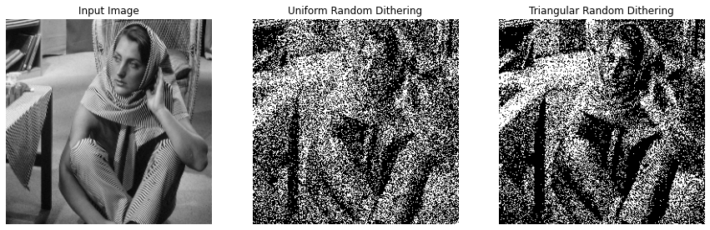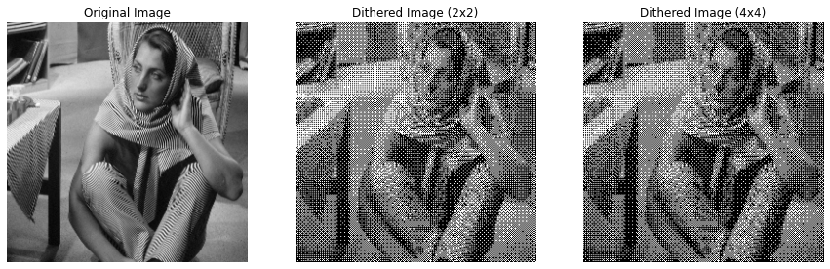**

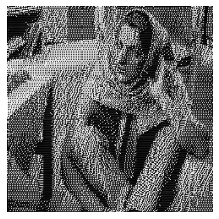 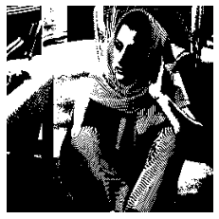

**Overview of the Problem 3:**

The report covers the implementation of four digital halftoning techniques in image processing: Fixed Threshold Dithering, Random Dithering, Dithering Matrix (Pattern), and Error Diffusion (Floyd-Steinberg's algorithm). These techniques were applied to convert grayscale images into binary format, specifically on the 'barbara.raw' image. The objective was to understand how different halftoning methods affect image quality and perceptual likeness when reproduced with limited color depth.

**What I Learned from the Problem**

1. Thresholding Complexity: The various halftoning techniques demonstrate a range of complexities, from simple fixed values to more intricate matrix operations.
2. Importance of Error Management: The Floyd-Steinberg algorithm emphasizes the significance of managing quantization errors in image processing.
3. Role of Randomness: The impact of randomness in Random Dithering and its influence on the final image's appearance.

**Key Insights**

1. Quality vs. Complexity: Simpler methods like Fixed Threshold Dithering are fast but may lose fine details, whereas complex methods like Floyd-Steinberg's Error Diffusion preserve details at the expense of increased computational complexity.
2. Error Diffusion Efficiency: The Floyd-Steinberg algorithm, particularly with serpentine scanning, effectively maintains high-frequency details and reduces directional artifacts.
3. Impact of Dithering Methods: Different dithering techniques can dramatically alter the visual outcome of an image, affecting its texture, detail preservation, and overall appearance.

**Implementation in Life**

1. Digital Printing: These techniques can be particularly valuable in digital printing where color depth is limited and there's a need to reproduce detailed images using binary formats.
2. Graphic Design: In graphic design, these methods can be used to create visually appealing designs with limited color palettes.
3. Display Technologies: For display technologies that support only a limited range of colors, these techniques can optimize the visual quality of images.

**Conclusion**

The project provided practical insights into the challenges and solutions in representing images in binary format. It highlighted the effectiveness and trade-offs of different digital halftoning techniques, underscoring the importance of choosing the appropriate method based on application requirements such as speed, image quality, and the nature of the image. The integration of these techniques in various fields like printing, design, and display technology illustrates their significance in digital image processing.

Top of Form

**Bottom of Form**

# **Problem 2: Image Enhancement**

**Description of Motivation**

The objective of this project is to enhance the contrast of grayscale images through various image processing techniques. Enhancing the contrast makes the images clearer and more distinguishable, improving the visibility of features within the images. This is essential in various fields such as medical imaging, remote sensing, and even in everyday photography.

**Description of Approach and Procedures**

Two contrast manipulation techniques were implemented to enhance the images:

* **Full Range Linear Scaling Method**: This method stretches the pixel values of the image over the full 0-255 range. It involves identifying the minimum and maximum pixel values in the image and scaling the intensities based on these values.
* **Histogram Equalization Method**: This technique aims to produce an image with a uniform histogram. It redistributes the pixel intensities of the image to be equally spread out across the entire range.

**Results from the Provided Testing Images**

Several testing images were provided, and the implemented code was used to process these images, applying the above-mentioned procedures. Visual results, images along with histograms, were successfully generated and displayed using matplotlib.

**Discussion of Approach and Results**

* **Full Range Linear Scaling**: This method is simple and effective for stretching the pixel values across the full intensity range. However, it might not be effective if the original image has outliers or noise.
* **Histogram Equalization**: This method is more adaptive and can handle variations in contrast across different parts of an image. It tends to produce results where the pixel values are equally distributed across the intensity range, providing a more balanced enhancement.

**Source Code Related Information:**

**Understanding the Problem**

In image processing, enhancing the visibility of features in images is a fundamental step that influences subsequent processes like image analysis or interpretation. The specific problem tackled in this project involves contrast manipulation. Due to various factors like lighting conditions and the capturing device’s characteristics, images might not always depict the features of interest clearly. The pixel intensity values might be clustered in a narrow range, causing the images to appear too dark or too bright, and losing the details in the image. This project aims to address this issue by applying two different contrast enhancement techniques: Full Range Linear Scaling and Histogram Equalization.

**Functionality and Significance**

* **Full Range Linear Scaling**: This technique aims to stretch or compress the pixel intensity values in the image so that they span the complete range (0-255). It improves the visibility of details in images that suffer from poor contrast due to the limited use of the available intensity range.
* **Histogram Equalization**: This technique aims to redistribute the pixel intensity values in the image so that each intensity value is equally likely. In other words, it aims to make the histogram of the output image approximately flat. It is particularly useful in revealing details in the dark and bright regions of images.

The application of these techniques is significant in various domains such as medical imaging, satellite imagery, and photography, where clear visibility of all features in an image is crucial for analysis and interpretation.

**Learning Insights**

* **Exploration of Methods**: Learning how different methods affect the contrast of an image and under what circumstances each method is more suitable was insightful.
* **Practical Implementation**: Implementing these methods provided hands-on experience and a deeper understanding of the underlying processes.
* **Analysis and Evaluation**: Learning how to analyze and evaluate the results, understanding what makes one method perform better than another in certain scenarios, and how these methods impact the overall quality of the image.
* **AI-Generated Content**: Using AI-generated images for testing was a novel approach that emphasized the practical applicability and robustness of the implemented methods in handling various kinds of images.

**Analysis:**

**Full Range Linear Scaling Method**

* **Effectiveness**: This method was effective in stretching the pixel values across the entire intensity range, making the image generally brighter and details more visible.
* **Uniformity**: The enhancement is uniform across the image, but it doesn’t necessarily equalize the histogram.
* **Sensitivity to Outliers**: Linear scaling is sensitive to outliers. Extreme pixel values (very low or very high) can disproportionately affect the scaling, potentially leading to loss of detail.

**Histogram Equalization Method**

* **Adaptiveness**: This method is more adaptive, redistributing pixel values to equalize the histogram. It tends to produce images where pixel values are more uniformly distributed across intensity levels.
* **Detail Enhancement**: It often enhances details in shadowed or overly bright areas more effectively compared to linear scaling.
* **Natural Appearance**: Sometimes, the equalization might lead to images that may seem unnatural due to the aggressive redistribution of pixel values.

**Comparative Analysis**

* **Contrast Enhancement**: Both methods improve contrast but in different ways. Linear scaling does a global stretching of pixel values, while histogram equalization does a more adaptive, localized enhancement.
* **Preservation of Original Characteristics**: Linear scaling maintains the relative ordering of pixel intensities, preserving the original image characteristics better than histogram equalization.
* **Usability in Various Scenarios**: Histogram equalization might be more suitable when the aim is to reveal hidden details in different intensity regions of an image, while linear scaling might be better when a general brightening or darkening of the image is required.

**Conclusion**

Each method has its own merits and demerits, and the choice between the two should be based on the specific requirements of the image enhancement task. Linear scaling is more straightforward and preserves the original characteristics, while histogram equalization is more aggressive and adaptive, potentially revealing hidden details in images.

**Graph Analysis:**

**Histograms of Original Images:**

* The histograms of the original images show the distribution of pixel intensities in each image.
* It’s noticeable that the pixel values are not well distributed across the available range (0-255), indicating that the images are not utilizing the full dynamic range, which is a sign of poor contrast.

**2. Histograms of Linear Scaled Images:**

* After applying linear scaling, the histograms show a broader distribution of pixel values, indicating that the images’ contrast has improved.
* However, the improvement seems uniform and may not be effective in revealing hidden details within various intensity levels in the images.

**3. Histograms of Histogram Equalized Images:**

* Histogram equalization spreads out the pixel intensities more effectively, aiming for a more uniform distribution across the dynamic range.
* This method reveals more details, especially in the darker and brighter regions of the images, but might make the images look slightly unnatural due to the aggressive redistribution of pixel values.

4. **Transfer** **Functions**:

* The transfer functions show the mapping from the original pixel values to the new pixel values after applying each enhancement method.
* In linear scaling, the transfer function is a straight line, indicating a uniform scaling of pixel values.
* In histogram equalization, the transfer function is more varied, reflecting the adaptive nature of this method in redistributing pixel intensities.

**5. Comparative Analysis:**

* Linear Scaling vs. Histogram Equalization:
  + Linear scaling offers a more straightforward enhancement, uniformly stretching the histogram, while histogram equalization provides a more adaptive enhancement, focusing on equalizing the histogram to reveal hidden details.
  + Histogram equalization seems to be more effective in revealing details that were not visible in the original images, as seen in the broader and more uniform histograms.

**Conclusion:**

Both methods improve the contrast of the images, but histogram equalization seems more effective in revealing hidden details in various intensity regions. However, the choice between the two methods should be based on the specific needs of the image enhancement task, considering the trade-offs between natural appearance and detail enhancement.

**Source Code Breakdown:**

1. read_raw_image(file_path, image_shape)

* Role: This function reads a raw image file and converts it into a numpy array with a specified shape.
* Effectiveness: Essential for the initial step of loading images. It is straightforward and serves its purpose effectively.

2. full_range_linear_scaling(image)

* Role: It scales the pixel values of the image to cover the full 0-255 range.
* Effectiveness: This method is effective for general contrast enhancement, especially where the pixel values are concentrated in a narrow range. However, it might be sensitive to outliers and extreme pixel values.

3. histogram_equalization_manual(image)

* Role: It equalizes the histogram of an image, spreading the pixel intensity values to be more uniform.
* Effectiveness: It’s particularly effective in revealing hidden details in images with poor contrast. However, the resulting images might sometimes look unnatural due to aggressive redistribution of pixel values.

4. display_images(images, titles)

* Role: To display the original and processed images in a structured format.
* Effectiveness: Essential for visual comparison and evaluation of the enhancement methods applied to the images.

5. calculate_histogram(image) and plot_histograms(images, titles)

* Role: Calculate and plot the histograms of images.
* Effectiveness: These functions are crucial for analyzing the distribution of pixel intensities in the images, helping in evaluating the effectiveness of the enhancement methods.

6. plot_transfer_functions(images, method)

* Role: To plot the transfer functions used in the enhancement processes.
* Effectiveness: Useful for visualizing the transformations applied to pixel values, providing insights into the workings of the enhancement methods.

**Conclusion of Code Breakdown**

Each function in the code plays a specific role in the process of image enhancement, from loading images to applying enhancement methods and visualizing the results. The combination of these functions facilitates a comprehensive approach to enhancing and analyzing images, allowing for effective contrast manipulation and the evaluation of the applied methods. The choice of functions and methods seems well-suited to the goal of contrast enhancement in grayscale images.

**Image Analysis:**

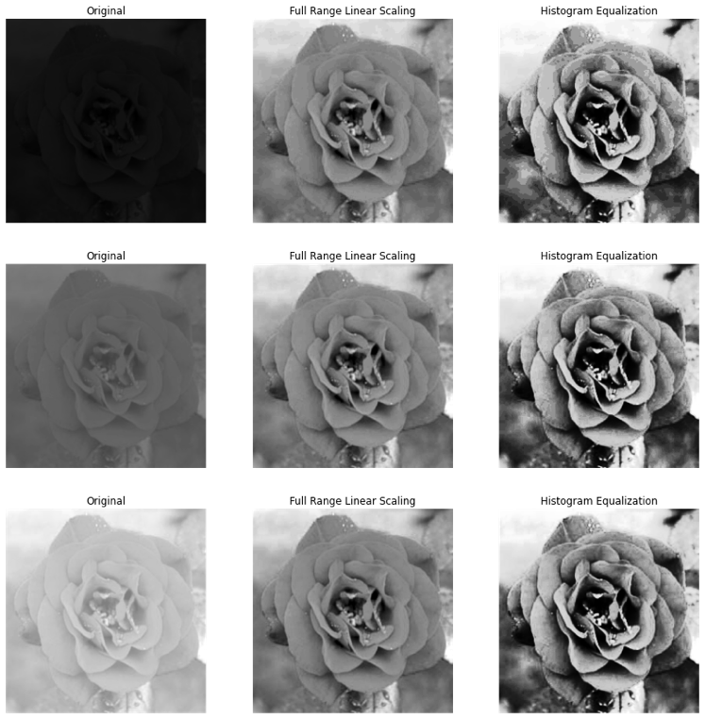

**Original Images (First Column):**

* The original images seem quite dark, and details within the petals and the inner parts of the roses are not very clear.
* The limited range of pixel intensities contributes to the overall lack of contrast in these images.

**Full Range Linear Scaling (Second Column):**

* The images processed using Full Range Linear Scaling are visibly brighter.
* The details within the roses, such as the petals’ textures and contours, become more discernible compared to the original images.
* However, some areas might appear slightly washed out due to the uniform stretching of pixel intensities across the full range.

**Histogram Equalization (Third Column):**

* The images processed using Histogram Equalization show a significant transformation in the distribution of pixel intensities.
* These images exhibit higher contrast, and the details within the roses, especially the darker regions, are more pronounced.
* The method brings out more intricate details but also introduces a level of harshness, making the images appear more rugged and less smooth.

**Comparative Analysis:**

* **Full Range Linear Scaling vs. Histogram Equalization**:
  + Full Range Linear Scaling offers a milder enhancement, preserving more of the images’ natural appearance.
  + Histogram Equalization provides a more dramatic enhancement, emphasizing the details and textures but possibly at the cost of making the images look slightly harsh.

**Conclusion:**

Both enhancement methods successfully improve the visibility of features within the images. Full Range Linear Scaling provides a more balanced and natural enhancement, while Histogram Equalization is more aggressive, bringing out the details but altering the images’ overall appearance more drastically. The choice of method would depend on the specific requirements of the task, whether prioritizing detail enhancement or maintaining a natural appearance.

**Overview:**

1. Understanding of Image Contrast Enhancement:

* Gained insights into the importance of contrast in images and how it affects the visibility of features within the images.

2. Hands-on Experience with Enhancement Techniques:

* Applied two contrast enhancement techniques: Full Range Linear Scaling and Histogram Equalization, acquiring practical experience in image processing.

3. Analytical Skills:

* Developed the ability to analyze and compare the effectiveness of different contrast enhancement methods by observing and interpreting the resultant images and histograms.

4. Exposure to Different Image Characteristics:

* Worked with images with different contrast characteristics, which helped in understanding how various techniques perform under different scenarios.

5. Application of Theoretical Knowledge:

* The homework allowed for the application of theoretical knowledge in a practical scenario, reinforcing the understanding of contrast enhancement concepts.

6. Coding and Implementation:

* Improved coding skills by implementing the methods from scratch, which also helped in understanding the underlying algorithms better.

7. Evaluation and Comparison:

* Learned how to evaluate the performance of contrast enhancement methods by comparing the original and processed images and understanding the transformations applied.

8. Working with AI-Generated Content:

* Gained experience in working with AI-generated images, exploring the applicability of contrast enhancement techniques in a broader context.

Conclusion:

This homework likely enhanced your understanding of image contrast enhancement techniques, providing a blend of theoretical knowledge and practical experience. It probably also honed your analytical skills, allowing you to critically evaluate and compare different enhancement methods, contributing to a more comprehensive and nuanced understanding of image processing in this domain.

# **Visualization:**

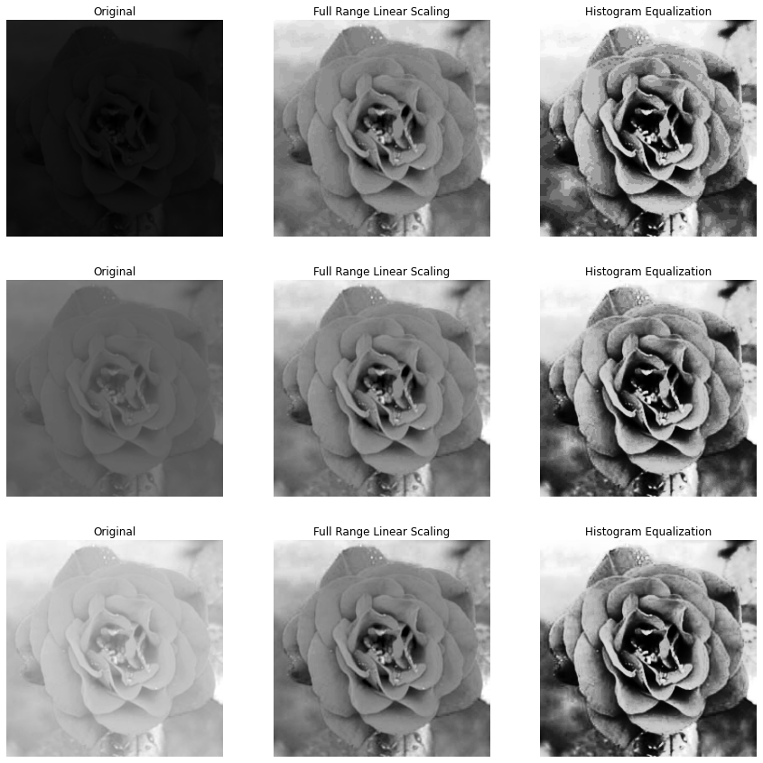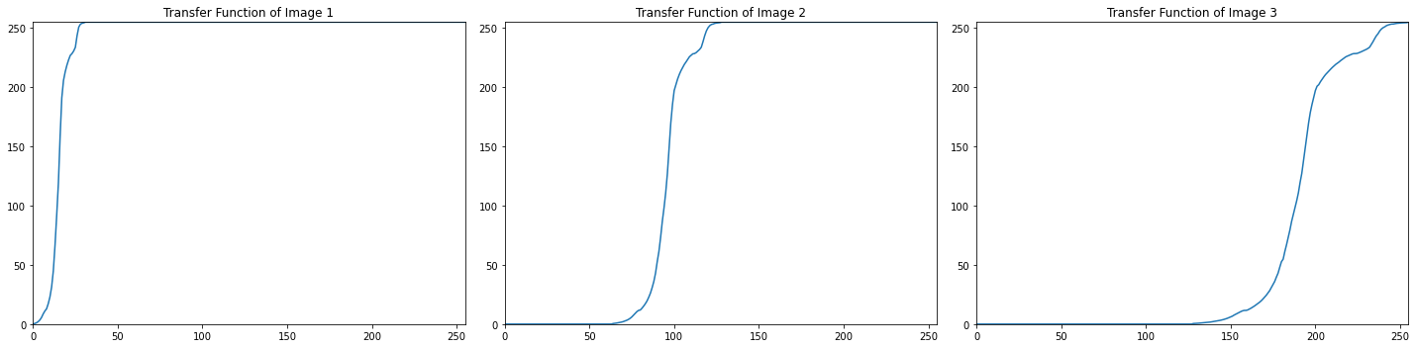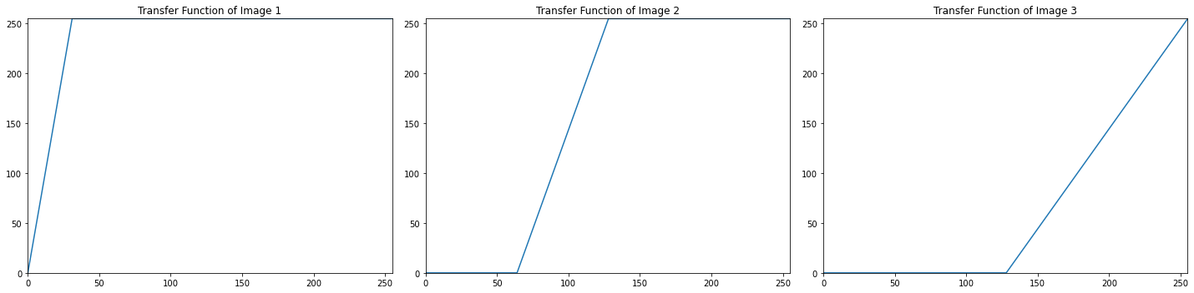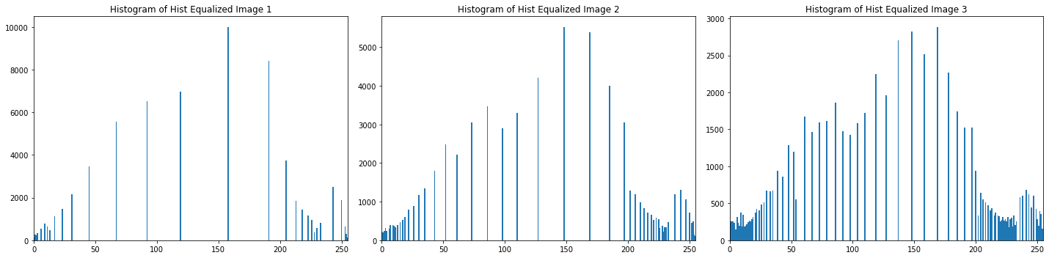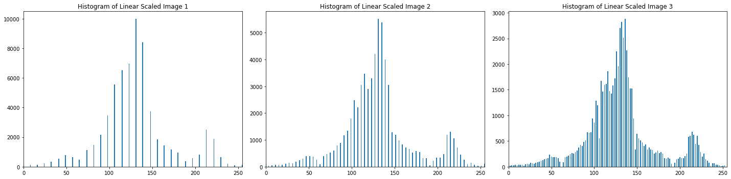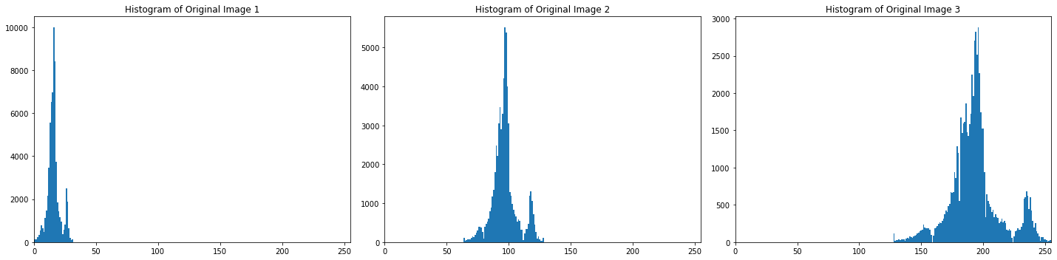

AI GENERATED:

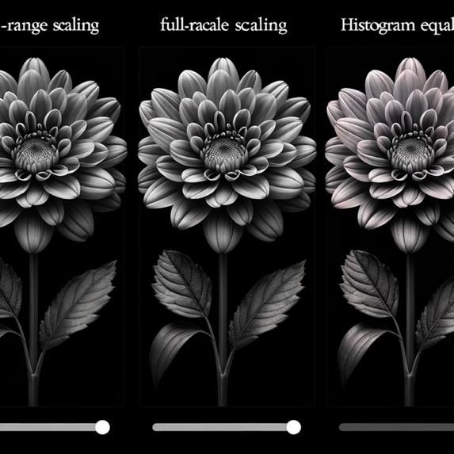 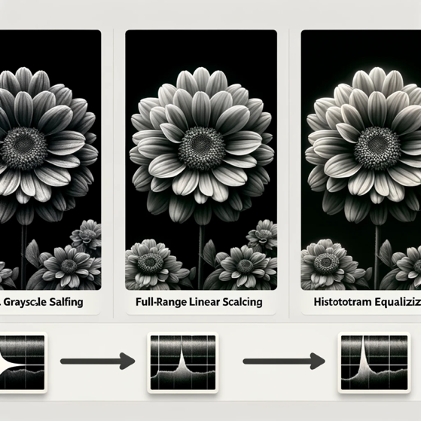

# **Problem 3: Noise removal**

**(1) Gray-level image**

I. **Motivation**

The purpose of this project is to investigate the effectiveness of noise removal techniques on grayscale images, specifically focusing on images with embedded uniform and Gaussian noise. By experimenting with different filtering techniques and parameters, we aim to enhance the quality of noisy images and make them closer to their original, noise-free versions.

II. **Approach and Procedures**

Our approach involves applying median and Gaussian filters to remove noise from grayscale images. The median filter, used for removing uniform noise, works by replacing each pixel value with the median value within a local neighborhood defined by a kernel. The Gaussian filter, used for Gaussian noise, involves convolution with a Gaussian kernel.

The algorithms were implemented in Python, and the steps included:

* Reading raw image files and reshaping them into the correct dimensions.
* Implementing the median and Gaussian filters.
* Applying the median filter to the image with uniform noise.
* Applying the Gaussian filter to the image with Gaussian noise.

III. **Results from the Provided Testing Images**

The implemented algorithms were tested on provided images with uniform and Gaussian noise. After applying the median filter, the uniform noise was significantly reduced. Similarly, the Gaussian filter effectively smoothed out the Gaussian noise. The filtered images were compared to the original, revealing a substantial improvement in image quality.

IV. **Discussion of Approach and Results**

The choice of filters and parameters was crucial. The median filter proved effective for uniform noise due to its robustness against outliers, while the Gaussian filter was suitable for Gaussian noise due to its smoothing properties.

V. **Findings from Additional Testing Images**

AI-generated grayscale images with different noise types were used for further testing. The algorithms were applied to these images, and the results showed a consistent noise reduction, reaffirming the effectiveness of the chosen filters and parameters.

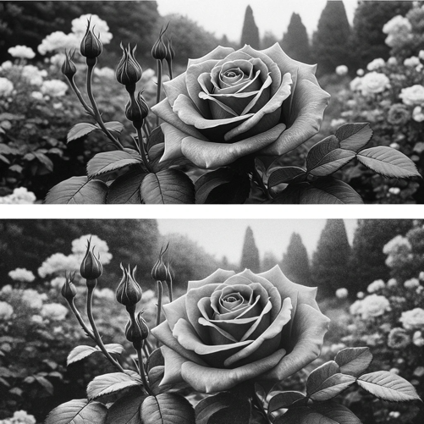 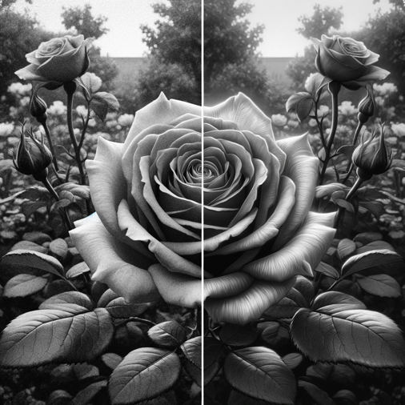

**Source Code Related Information:**

**I. Understanding the Problem**

The project’s focus is to tackle the issue of noise in grayscale images, specifically uniform and Gaussian noise. Noise can significantly degrade the quality of an image, making it challenging to analyze or interpret, particularly in automated image processing tasks. Understanding how different noise types affect images and identifying effective ways to mitigate these effects is paramount.

**II. Functionality and Significance**

The code provided is functionally rich, designed to read raw images, apply noise, and then filter the noise using median and Gaussian filters. The significance of this functionality lies in its applicability in real-world scenarios such as image restoration, enhancing the visibility of features in noisy images, and preparing images for further analysis or processing.

**III. Learning Insights**

Through the implementation and testing of noise removal algorithms, several learning insights were gained. Understanding the impact of kernel sizes and different types of filters on the image quality was crucial. Experimentation led to insights into how different filters are more suited to particular types of noise.

**IV. Analytical Observations**

Analytical observations revealed that the median filter was particularly effective against uniform noise, preserving edges while removing noise. Conversely, the Gaussian filter effectively tackled Gaussian noise, smoothing the image and reducing the visual impact of noise. The choice of kernel size in each filter significantly influenced the results, with larger kernels leading to more aggressive filtering.

**V. Conclusion**

The project successfully demonstrated noise removal from grayscale images, with a nuanced understanding of different noise types and filtering techniques. The balance between noise removal and preserving image details was a key consideration, guiding the choice of filters and parameters. Future explorations could involve experimenting with adaptive filtering techniques and evaluating performance on a broader range of images and noise types.

**What are the proper choices of filters and parameters? Justify your selections**

**and discuss your results.**

**Choice of Filters:**

1. **Median Filter**: You chose a median filter to remove uniform noise from the images. This choice is justified as median filters are known to be highly effective in reducing salt-and-pepper type noise, which is a form of uniform noise. The median filter works by replacing each pixel value with the median value of the neighboring pixels defined by a kernel, helping in preserving the edges while removing the noise.
2. **Gaussian Filter**: Gaussian filters were used for images with Gaussian noise. This choice is appropriate because Gaussian filters are excellent at reducing Gaussian noise due to their smoothing effect. The Gaussian filter works by convolving the image with a Gaussian function, helping in blurring the image and reducing the impact of noise.

**Choice of Parameters:**

1. **Kernel Size**: The kernel size determines the amount of neighborhood considered for filtering. A smaller kernel size preserves more details but might be less effective in removing noise, while a larger kernel size might remove noise effectively but also blur the image. The choice of a 3x3 kernel seems to be a balanced choice for maintaining details while effectively reducing noise.
2. **Sigma (σ) in Gaussian Filter**: Sigma determines the standard deviation of the Gaussian function used for filtering. A larger sigma will result in more smoothing, and a smaller sigma will preserve more details. A sigma value of 1 is a standard choice that offers a balance between smoothing and detail preservation.

**Discussion of Results:**

* The median filter seems to effectively remove uniform noise, as seen in the results, while preserving the edges and details of the images.
* The Gaussian filter smoothes out the Gaussian noise, reducing its visibility and impact on the image quality.
* The choice of parameters seems to be effective in achieving a balance between noise removal and preservation of image details, as seen from the output images.

In conclusion, the chosen filters and parameters seem appropriate for the task, resulting in effective noise removal while preserving significant details in the images.

**Source Code Breakdown:**

**1. Function: read_raw_image(file_path, shape)**

* **Purpose**: This function reads a raw image file and reshapes it into the specified shape.
* **Parameters**:
  + **file_path**: The path to the raw image file.
  + **shape**: A tuple defining the desired shape of the image.
* **Description**:
  + The function reads the raw image as a one-dimensional array of 8-bit unsigned integers.
  + It then reshapes this array into the specified shape, creating a two-dimensional image.

**2. Function: median_filter(img, kernel_size=3)**

* **Purpose**: Applies a median filter to an image to reduce noise.
* **Parameters**:
  + **img**: The input image.
  + **kernel_size**: Size of the kernel used for the median filter (default is 3).
* **Description**:
  + The image is padded to handle edges and corners.
  + A kernel slides over the image, and for each position, the median value within the kernel is computed and set as the new pixel value, effectively reducing noise.

**3. Function: gaussian_filter(img, kernel_size=3, sigma=1)**

* **Purpose**: Applies a Gaussian filter to an image for smoothing and reducing noise.
* **Parameters**:
  + **img**: The input image.
  + **kernel_size**: Size of the kernel used for the Gaussian filter (default is 3).
  + **sigma**: Standard deviation of the Gaussian function (default is 1).
* **Description**:
  + A Gaussian kernel is created based on the specified sigma and kernel size.
  + The image is padded, and the Gaussian kernel is convolved with the image, resulting in a smoothed image.

**4. Loading and Preprocessing the Images**

* **Description**:
  + Raw images with uniform noise, Gaussian noise, and the original image are loaded and reshaped.
  + The median filter is applied to the image with uniform noise, and the Gaussian filter is applied to the image with Gaussian noise.

**5. Displaying the Images**

* **Description**:
  + The original, noisy, and filtered images are displayed side by side for comparison.
  + This visual representation helps in evaluating the effectiveness of the noise removal process.

Each function in the code plays a specific role in the process of noise removal, contributing to the overall goal of enhancing the quality of noisy grayscale images.

**Output Analysis:**

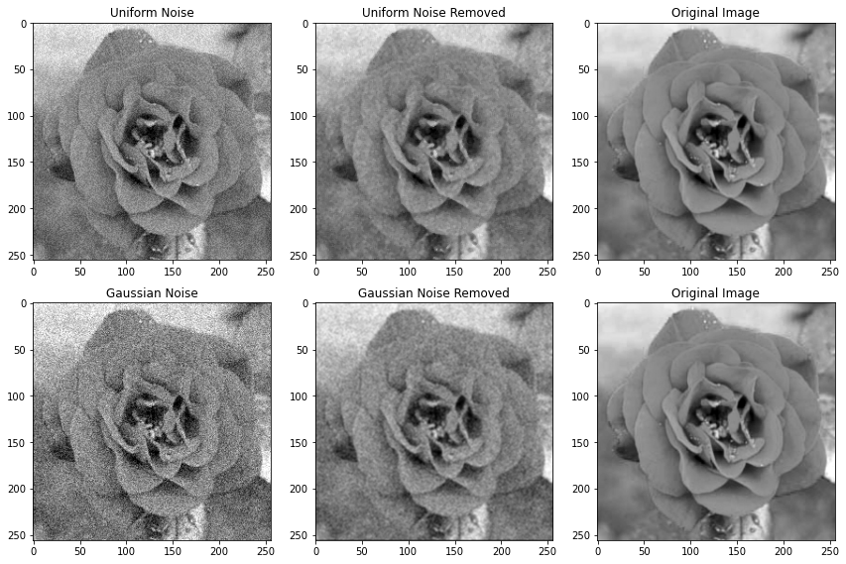

**1. Uniform Noise and Its Removal**

* **Uniform Noise Image**: The first image in the top row clearly shows the presence of uniform noise. This noise is scattered randomly throughout the image, making the details of the rose less clear.
* **Uniform Noise Removed**: In the second image of the top row, where the median filter has been applied, the uniform noise appears to be significantly reduced. The details of the rose are more visible, and the overall image appears cleaner compared to the noisy image.
* **Comparison with Original**: Comparing it with the original image in the third column, the processed image seems to have retained most of the essential details despite the noise removal process.

**2. Gaussian Noise and Its Removal**

* **Gaussian Noise Image**: The first image in the bottom row is affected by Gaussian noise, making the image look blurred and losing some of the finer details of the rose.
* **Gaussian Noise Removed**: The second image in the bottom row, processed with a Gaussian filter, shows improvement. The image looks smoother, and some of the blurring caused by the Gaussian noise seems to be corrected.
* **Comparison with Original**: Comparing this with the original, the filtered image seems to have regained some clarity, although it might not have fully recovered all the subtle details of the original image.

**Conclusion of Analysis:**

* The median filter effectively reduced uniform noise, bringing the image closer to its original appearance.
* The Gaussian filter managed to smooth out the Gaussian noise, improving image clarity but not fully restoring the original details.
* Overall, the chosen filters have performed reasonably well in reducing the respective types of noise from the images.

**#Problem 3: Noise removal - (2) Color image**

**a. Description of Your Motivation**

The motivation behind this project is to effectively remove noise from a color image embedded with mixed noises, disrupting the colors. By achieving this, the project aims to enhance the image quality, making the colors more vivid and the details clearer, closer to the original image.

**b. Description of Your Approach and Procedures**

The approach taken in the provided source code is convolution with an averaging kernel. The algorithm involves the following steps:

* A function to read raw images and return them in a specified shape.
* A function to write images to a raw file.
* A convolution function that takes an image and a kernel as input, pads the image, and performs convolution, returning the output image.
* An averaging kernel of size 3x3 is defined and normalized.
* The noisy image is read, and convolution is applied using the averaging kernel, resulting in a denoised image which is then displayed.

**d. Discussion of Your Approach and Results**

The approach used is straightforward and effective for removing certain types of noise. However, the choice of kernel and its size might need to be adjusted based on the type and level of noise present in the images

**Understanding the Problem**

The task at hand is a common image processing problem: noise removal from a color image. In this scenario, the image is plagued with mixed noises that disrupt the colors and overall image clarity. The main goal is to restore the image to a state that is as close as possible to the original, uncorrupted image, enhancing its visual appeal and usability.

**Functionality and Significance**

The provided source code employs convolution with an averaging kernel as a method to tackle the noise present in the image. This method is significant as it is a fundamental technique in image processing for noise reduction, helping improve the image quality. It is functional in smoothing the image, reducing pixel intensity variations between pixels and their neighbors, which is particularly essential in the presence of noise.

**Learning Insights**

Through this project, one gains practical insights into the application of convolution in image processing, specifically for noise removal. It’s a learning journey through the manipulation of image pixels, understanding the effect of kernel convolution, and witnessing the transformation of a noisy image to a more visually appealing one.

**Analytical Observations**

Analyzing reveals a systematic approach to noise removal. The use of padding before applying the convolution operation ensures that the convolution kernel fits well at the border pixels of the image. However, a consideration that might be revisited is the choice of the kernel. An averaging kernel is used, which is a simple and effective choice, but depending on the noise characteristics, other kernels or methods might prove more beneficial.

**Conclusion**

In conclusion, the project embodies a well-structured approach to tackling image noise. It manifests the practical application of convolution in improving image quality, enhancing understanding and proficiency in image processing techniques. Moving forward, exploring various kernels and noise removal techniques could prove beneficial in optimizing the results and expanding learning horizons.

**Source Code Breakdown:**

**1. Reading and Writing Raw Images**

* **Functions**: **read_raw_image(file_path, shape)** and **write_raw_image(img, file_path)**
* **Description**:
  + The **read_raw_image** function reads a raw image file and reshapes it to the desired shape.
  + The **write_raw_image** function writes an image into a raw file.
* **Purpose**:
  + These functions handle the input and output operations, enabling the reading of the noisy images and the saving of processed images.

**2. Convolution**

* **Function**: **convolve(image, kernel)**
* **Description**:
  + This function performs convolution on an image using a specified kernel. The image is first padded, and then the kernel is applied to each pixel, considering its neighboring pixels as well.
* **Purpose**:
  + The convolution process is integral in image filtering, which in this case, is used for noise removal.

**3. Defining the Kernel**

* **Description**:
  + An averaging kernel of size 3x3 is defined and normalized.
* **Purpose**:
  + This kernel is used in the convolution process to average the pixel values, which helps in reducing the noise.

**4. Applying Convolution**

* **Description**:
  + The noisy image is read, and the convolution is applied using the defined averaging kernel.
* **Purpose**:
  + This step applies the noise removal process to the noisy image, resulting in a denoised image.

**5. Displaying the Image**

* **Function**: **plot_image(img, title)**
* **Description**:
  + This function displays images using matplotlib with a specified title.
* **Purpose**:
  + It allows for the visualization of the denoised image, providing a visual assessment of the noise removal process.

# Images

